

**School of Computing**

**SRM IST, Kattankulathur – 603 203**

**Course Code: 18CSC206J**

**Course Name: Software Engineering and Project Management**

| **Experiment No** | 9 |
| --- | --- |
| **Title of Experiment** | Design a Sequence and Collaboration Diagram |
| **Name of the candidate** | VELLANKI VENKAT ADITYA |
| **Team Members** | PARAS PAL, M.V. MANISH |
| **Register Number** | RA2111003011799, RA2111003011818, RA2111003011819 |
| **Date of Experiment** | 20-04-2023 |

**Mark Split Up**

| **S. No** | **Description** | **Maximum Mark** | **Mark Obtained** |
| --- | --- | --- | --- |
| 1 | Exercise | 5 |  |
| 2 | Viva | 5 |  |
| **Total** | | **10** |  |

**Staff Signature with date**

**Aim**

To create the sequence and collaboration diagram for the <project name>

**Team Members:**

| **S No** | **Register No** | **Name** | **Role** |
| --- | --- | --- | --- |
| **1** | **RA2111003011818** | **PARAS PAL** | **Rep/Member** |
| **2** | **RA2111003011819** | **M.V.MANISH** | **Member** |
| **3** | **RA2111003011799** | **VELLANKI VENKAT ADITYA** | **Member** |

Sequence and Collaboration Diagram>

**SEQUENCE DIAGRAM TEMPLATE:**

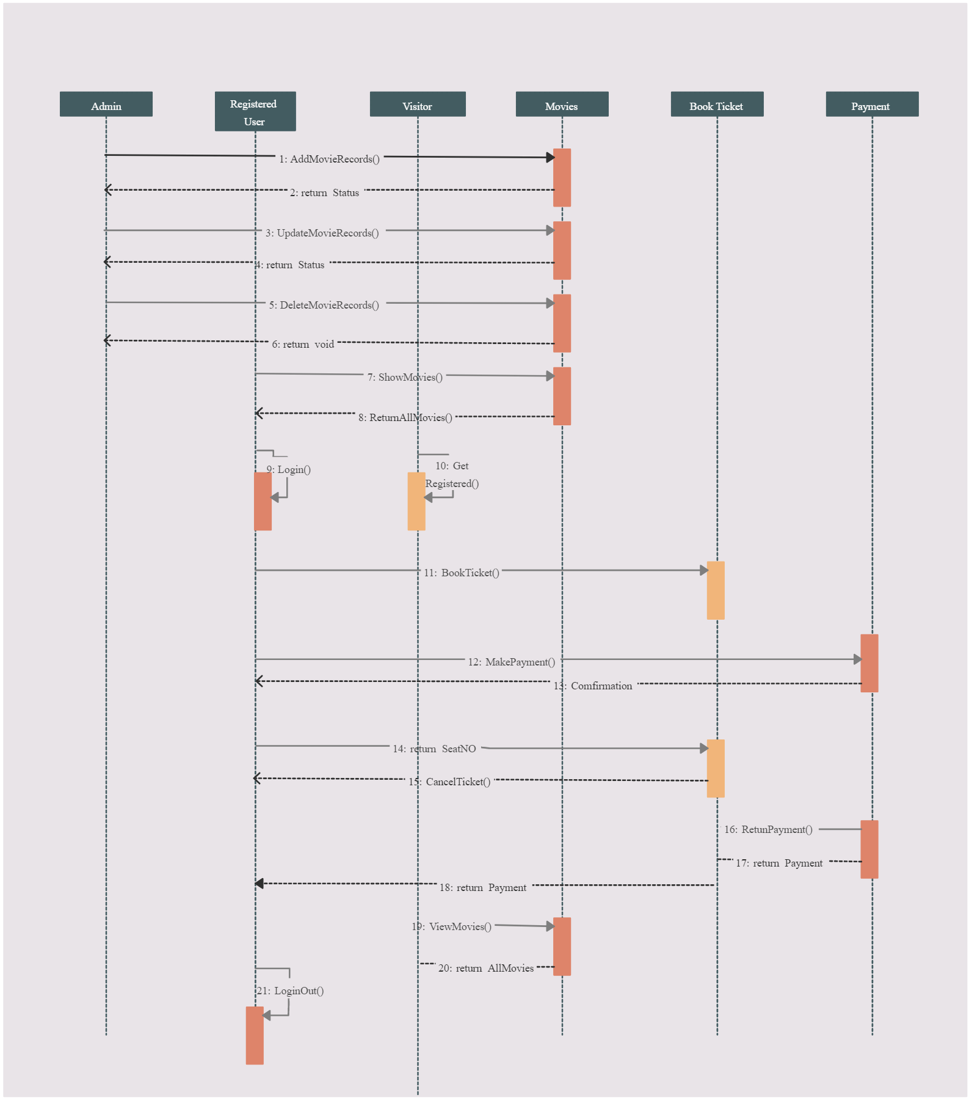

**SEQUENCE DIAGRAM:**

**ADMIN:**

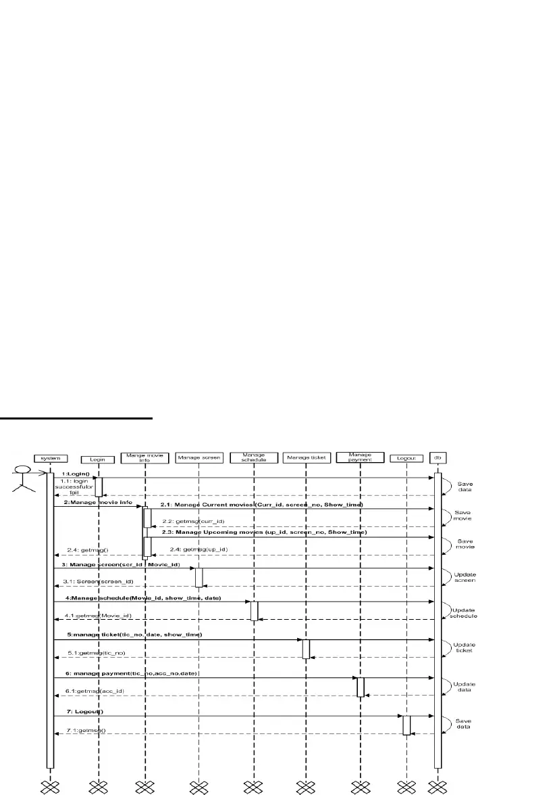

**SEQUENCE DIAGRAM:**

**MEMBER:**

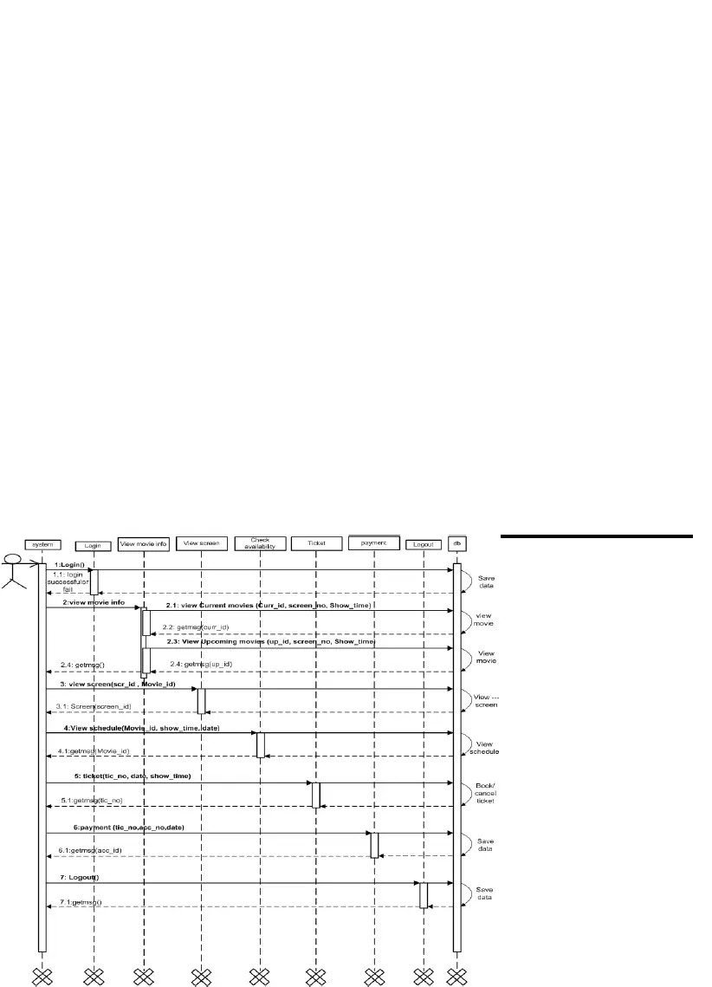

**COLLABORATION DIAGRAM:**

**ADMIN:**

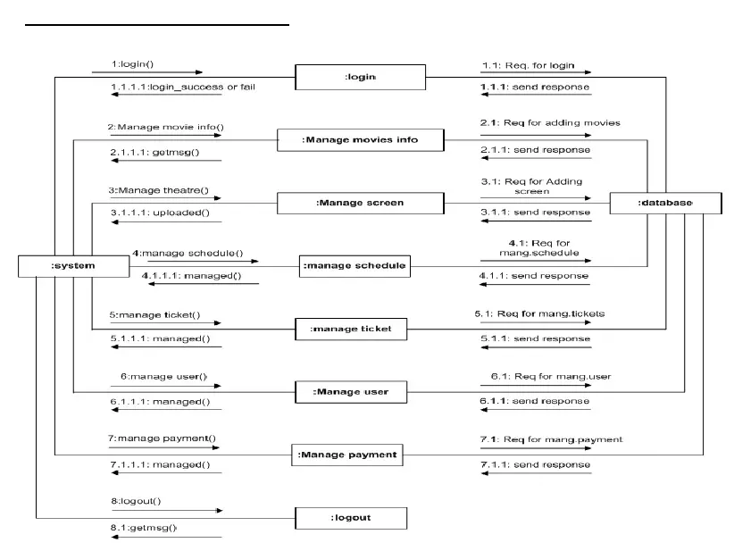

**COLLABORATION DIAGRAM:**

**MEMBER:**

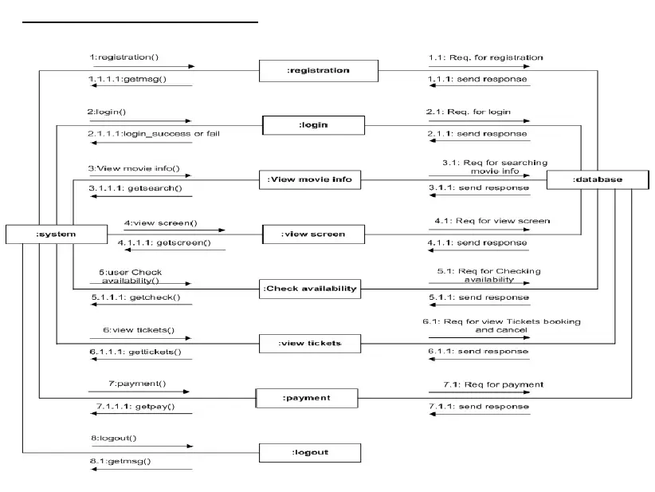

Result:

Thus, the sequence and collaboration diagrams were created for the movie booking system<cinepo>